Computer Networks Lab (CSE 324)

Assignment 1

Submitted By

0119113 Nahian Ahmed Rim

011201057 Niful Islam

Submitted To

## Farhanaz Farheen

What is NAT:

NAT refers to network address translation. It matches private ip to a registered public ip address and vice versa.

Why we need NAT

Ipv4 addresses can provide a maximum of 4294967296 devices. Due to large number of users and many devices getting connected to the internet, the number has address scheme outdated. In order to connect more devices with this technologies, we need private ip addresses. However, private addresses are not accessible from internet. That’s why NAT has been used to map private address to public address.

Our network

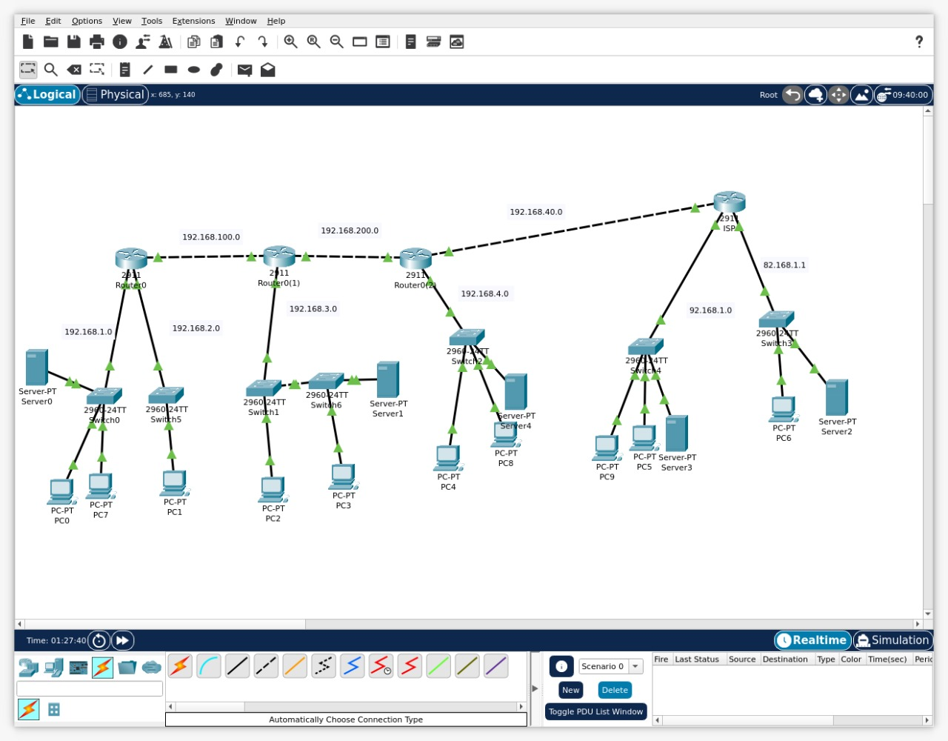

Here network 192.168.1.0 is being used as a private address. PAT translates this address to a public ip .